Abingdon Farmers Market
Vendor Application 2025 for Treasurer use only
“Always Fresh, Always Local” Date_______________
Amt. paid in Cash_______________
Check # and amount_______________
David McLeish, Market Manager
276-698-1434
abingdonmarket@gmail.com
www.abingdonfarmersmarket.com
All items for sale at the AFM must be locally produced. The use of as many locally produced ingredients as possible is strongly encouraged in all baked goods, beverages and other prepared foods. Items not raised by the vendor, their family, or employees at the addresses listed below must have written approval for sale by the Market Manager/Steering Committee.
Items may not be purchased elsewhere for resale at the Abingdon Farmers Market.

Name(s):________________________________________________________________
Farm/Business name:_____________________________________________________
Mailing Address: ________________________________________________________
All Address(es) where you grow/make your products: ________________________________________________________________________________________________________________________________________________
County: ________________________________________________________________
Email: _________________________________________________________________
Home Phone: ___________________________________________________________
Work Phone: ____________________________________________________________
Check below to opt in:
□ The AFM may share my contact information with other AFM vendors.
□ The AFM may share my contact information with AFM patrons.

Primary Products*: Due to limited space, the AFM maintains a specific number of vendors in each of the categories listed below. Please check the MAIN CATEGORY that represents the primary product(s) that you intend to bring to the market in 2025, and list them in the space provided. Refer to 2025 Market Rules enclosed for guidance on vendor categories. If at any time you need to change this category, it must be approved by the market manager.
Select only 1 Category:
□ Farm Products □ Prepared Foods □ Arts & Crafts
__________________________________________________________________________________________
__________________________________________________________________________________________
__________________________________________________________________________________________

*Please understand that vendor product mixes are observed throughout the season. Changes in your primary/any additional product ratio could result in a change in your vendor status.
Have you previously vended at the AFM? □ Yes □ No

Space Location: All vendors are Required to attend the space selection meeting .
Please use the attached map of the AFM Pavilion to indicate your first three (3) choices of space location. In assigning vendor spaces, the AFM Steering Committee will make every effort to match vendors with their preferred locations. Requesting a range of spaces aids this, as well as your attendance at the meeting. Due to high demand and limited space, we cannot guarantee that vendors will receive their requested locations.

1st Choice _________ 2nd Choice ____________ 3rd Choice: ____________ We recommend a range of spaces, such as 28-34, etc. Please find our space map included. If you have special needs (handicap access, electricity, water, etc.) please explain: _______________________________________________________________________

Please indicate when you plan to start coming to the market, when your season will end and which market days you will attend.
Starting Date(s) __________; _____________
Ending Date(s) __________; _____________ Saturday Tuesday Both

AFM Vendor Space costs:

____ $10 Each Tuesday
____ $15 Each Saturday
__x_ $25 Membership Fee [required with all applications, nonrefundable]
$______ Total (**Minimum $100 due- includes membership fee & $75 Space Deposit)
**See 2025 Abingdon Farmers Market Fee Schedule for details
Returned check fee: $35

Failure to Pay the Vendor Space Fee by the dates and times listed may result in Late Fee and/or Vendor Point penalties or not being allowed to set up at the market, based on AFM Market Rules.

By signing this application and paying fees, I agree that I have read, understand, and agree to abide
by all the policies and rules set forth in the (current) Abingdon Farmers Market Rules (and Bylaws).

Signature: ____________________________________________________ Date: _________________

If under 18, Parent or Guardian Co-Signature: ________________________Date: _________________

Applications can be mailed to AFM, P.O. Box 526, Abingdon, VA 24212 or handed in to AFM Market Manager during scheduled market times.

ALL FULL SEASON APPLICATIONS & FIRST PAYMENT DUE by 3rd Saturday in January 2025

Thank you for your efforts to continue to make AFM a great farmers market for our vendors and customers! You will receive an answer to your request with your space assignment letter, following the space selection event. Requests during the season are considered each month by the Market Manager and / or Steering Committee. If you have any questions, please contact our Market Manager at 276-698-1434, or Email abingdonmarket@gmail.com.

The Abingdon Farmers Market Map

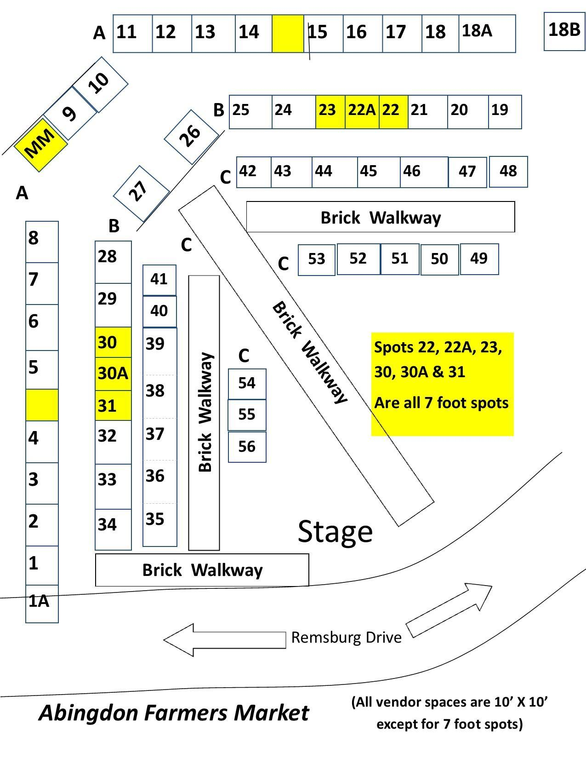

Abingdon Farmers Market Rules 2025
David McLeish, Market Manager 276-698-1434
abingdonmarket@gmail.com, www.abingdonfarmersmarket.com

Vendor Categories: In fulfillment of its mission, the AFM strives to maintain the following ratio of vendors at the Market: Farm Products (70%), Prepared Foods (15%) and Arts/Crafts (15%). See below for a description of items allowed in each category:
Farm Products: Products substantially grown, raised, or produced through agricultural activity, such as fruits, vegetables, plants, flowers, seeds, or animal products (50% of their life), including prepared foods and craft items made primarily from farm-raised or wild crafted items from the applicant’s farm. (Excludes wild crafted Mushrooms unless approved by USDA).
Prepared Foods: Homemade, edible items including *hot meals, candy, baked goods, jams, jellies, canned foods, and beverages. Use of locally produced ingredients is strongly encouraged. *Sale of Hot Meals requires a special permit from the Town of Abingdon https://abingdon-va.gov/food-truck-information.
Arts/Crafts: Non-edible handmade items such as carvings, artwork, jewelry, soaps, lotions, wreaths, etc. Use of local materials is strongly encouraged.
General rules for all vendors:
1. Items may not be purchased elsewhere for resale at the Abingdon Farmers Market.

2. Primary Products: On the application, vendors select one of the 3 vendor categories; Farm Products, Prepared Foods, or Arts & Crafts as their primary product to be sold at the Market. The majority of items brought to market over the entire season should reflect that primary category. The Market Manager will monitor these categories over the course of the season and reserve the right to re-categorize any vendors who have changed their primary products. If for any reason, the primary product needs to change during the season, the change must be approved by the Market Manager.

3. Compliance with all Health Department and Department of Agriculture guidelines and restrictions is the sole responsibility of each vendor, such as meat and egg temperature, organic labeling, etc. Upon request, vendors must demonstrate to the AFM Market Manager their compliance with all guidelines. All vendors who are planning to sell prepared food should contact Chris Salyer of the Virginia Department of Agriculture and Consumer Safety to discuss compliance with current inspection requirements. 276-220-3210 or Christopher.Salyer@vdacs.virginia.gov
Virginia’s Cottage Food Law lists prepared foods which may be sold at Farmers Markets without inspection:
http://lis.virginia.gov/cgi-bin/legp604.exe?131+ful+CHAP0285+pdf
Due to the family environment of the Abingdon Farmers Market, sales of any ingestible CBD, THC, or Delta products including any of their derivatives, as well as any other synthetic substances will be prohibited.

4. Only Meats processed in a USDA inspected facility that have a Dept. of Agriculture stamp, (except poultry and other meats exempted by VA law) are allowed on the AFM property and can be sold to or sampled by customers. All meat inspections are the responsibility of the vendor.

5. On behalf of the Steering Committee, the Market Manager has authority to inspect the origin of items sold at the Market to ensure that such sales conform to Market Rules. All vendors are subject to an on-site visit to verify local production at any point during the market season, including all sites of production. Routine farm visits are also ongoing, with the goal of visiting each farm every 2-3 years.

6. Any incident(s) of rule violation will be dealt with via the following:
---AFM Vendor Incident Form, filed by manager, with reply by vendor.
---AFM Vendor Complaint/Suggestion form, to be completed by both parties, and mediated by the manager and Facilitator (and others as requested, to be interviewed separately by manager.) Vendors involved in either of these processes have rights of appeal to the entire Steering Committee, after completion of the form and process above.
AFM Business Operations:
- Regular Season Saturday Markets will operate from the 1st Saturday in April through the last Saturday in October from 8:00am - 12:00pm unless otherwise stated in Market Manager weekly notes.
- Tuesday Markets will operate from the 1st Tuesday in April through the last Tuesday in September from 3:00pm – 6:00pm unless otherwise stated in Market Manager weekly notes.
- The Holiday Market will begin the first Saturday in November (Daylight Savings Time change) and run through Saturday prior to Christmas, from 10:00am - 12:00pm unless otherwise stated in Market Manager weekly notes. All AFM rules still apply.
- The Winter Market is open the first and third Saturdays of Jan, Feb, and March from 10:00am - 12:00pm unless otherwise stated in Market Manager weekly notes. All AFM rules still apply.
- Vendors will have access to the Market one (1) hour prior to the opening time for the purpose of unloading and setting up merchandise. Vendors must exit the premises no later than one half hour [1/2] after the closing time. Note that the Pavilion is often used for other events following the Market; prompt departure is appreciated.
- No sales may be made prior to the official announced market opening time. However, vendors may purchase prior to opening time to allow them to be at their space when the market opens.
- Vendors should deposit any checks received from the AFM (token reimbursements) in 30 days or less.
Fees:
Membership Fee must be paid with completed and signed Application - $25 (non-Refundable)

Vendor Space Fees:
____ $300 Full Season: Section A
____ $180 Full Season: Section B, and 18B (10-foot space) [spots 26 & 27 add $25}
____ $145 Full Season: Section B (7-foot space)
____ $150 Full Season: Section C (10-foot space along new walkway)
____ $ Full Season: Tuesday only—75% of above fees

Daily any space Saturday $15
Daily any space Tuesday $10

            - It is the sole responsibility of the vendor to make sure his/her fees are paid on time.
- Full-season fees include access to Holiday and Winter Markets.

Sales Tax:
Virginia State Law requires all vendors to register with the Virginia Department of Taxation, and to collect and report sales taxes. Information and applications can be obtained from the Virginia Department of Taxation, PO Box 1114, Richmond, VA 23218-1114. www.tax.virginia.gov Phone 804.440.2541. It is the responsibility of the individual vendor to comply with tax requirements.
Lease Agreements and Assignment of Space:
Full-season vendors will be assigned regular spaces at the space assignment meeting in March. All Vendors are required to attend and take part in this March meeting. All other available spaces shall be assigned by the Market Manager.

In assigning full season spaces, points are assigned for:
Location: 2 points Washington County, VA
Marketing Points: 1 point /year of tenure since 2007
1 additional point if Saturday season vendor in previous year [attendance for 75% of the regular season]
2 points if Tues season vendor in previous year has 75% Attendance April thru September
Or 3 points if Tues season vendor in previous year has 90% Attendance April thru September
1 additional point for 75% attendance at Holiday and Winter Markets, previous year.
Rule violations: 1 point deducted for each major infraction of rules in the previous year, pursuant to Vendor Incident and Vendor Complaint processes, to ensure due process for all involved.

AFM General Marketing Rules:
- Vending space size will be either 10’x10’ or 7’x10’.

- A 10-foot aisle down the middle of the pavilion must always be kept clear for pedestrian/customer use.

- The Market Manager, on behalf of the Steering Committee, reserves the right to cancel any lease, and to change space allocations when it is in the best interest of the Market operation.

- Vendors should be on-site and ready to sell no later than the start of the market. Attendance will be taken at the start of the market.

- If running late, any paid vendor may reserve his/her spot by contacting the Market Manager one Half hour before market opening. (No credit for attendance)

- If you are unable to attend any market date, please give the Market Manager as much advance notice as possible, at least one hour before market opening. So that another vendor has time to set up in that space.

- Failure to observe these policies will result in warnings from the AFM Manager. After a written warning for ‘no-shows, the Manager has the right to assign an empty space to another vendor on any given market day. A vendor arriving late, without any advance notice as above, may be assigned another space that day as available.

- Vendors arriving 3 times late will receive a written warning. After the 4th time late, they will be suspended for their next scheduled market.

- All vendors shall be held responsible for the actions of their employees, agents, or people working in concert with their stand.

- All vendors will leave their space clean and tidy, removing debris and trash. Brooms are available from the Market Manager.

- Proper dress and orderly space will be expected from all vendors. Proper language for a family atmosphere will be required.

- It is the responsibility of vendors to satisfy customer complaints. The Market Manager may cancel a vendor’s lease in the case of multiple customer complaints or if a vendor's activity jeopardizes the smooth operation of the Market.

- No person shall make a public outcry, do “hawking” or give any musical or other entertainment for the purpose of drawing customers or attracting attention.

- Item prices are suggested to be within the average range of other like items at the AFM. Samples given should be limited to small “tastes” with respect to other vendors selling the same items.

- All vendor signage must be contained within the vendor’s assigned rental space.

- No open flames (grills) are permitted on Market property without the prior approval of the Market Manager. https://abingdon-va.gov/food-truck-information/

Parking:
1. Vendor spaces will be assigned and reserved for their use only. Vendors are not permitted to park overnight at the market pavilion. Only the assigned vendor may park and sell from their reserved space. Only one (1) vehicle per vendor space behind the market pavilion.

2. All vehicles must enter and leave the Market area through the entrances and exits provided. Vendors will be expected to respect the parking regulations established by the Town of Abingdon and to park in such a way as to keep Market traffic lanes open for travel. This will be enforced by the Market Manager.

3. Each vendor must drive in a careful manner and at a rate of speed that does not endanger the property or people in and around the Market.

4. Handicap parking is available by request at the rear of the property.

5. Parking spaces behind pavilion are first come first serve. Please reserve spaces closest to the market for our customers. Please park at the Retina Physicians lot 166 Cummings Street (urban trail will bring you under Cummings Street), the National Bank parking lot, and as a last resort, along Remsburg Drive.

2025 Abingdon Farmers Market Fee Schedule
It is the sole responsibility of the vendor to make sure his/her fees are paid on time.

1st Payment:
- $25 Membership + $75 Space Deposit = $100.00 By 3rd Saturday in January
  - After 3rd Saturday in January the vendor must add a $50 late fee (does not count towards fee balance).
  - After 3rd Saturday in February the vendor must add a $50 late fee + vendor is moved to the bottom of the space selection list.
  - After 1st Saturday in March the vendor may only participate as a Daily Vendor but is responsible to pay Membership and Late Fees.

2nd Payment:
- Remainder of 1st half of your Season Space Fees are due by 3rd Saturday in April
  - After 3rd Saturday in April the vendor must add a $50 late fee (does not count towards fee balance).
  - After 4th Saturday in April vendor must add a $50 late fee + 1 point deduction from vendor points.
  - After 3rd Saturday in May vendor loses Season Space and may only participate as a

3rd Payment (if necessary):
- Remainder of Seasonal Space Fees based on selected space and prior payments are due by 1st Saturday in July.
    - After 1st Saturday in July the vendor must add a $50 late fee (does not count towards fee balance)
    - After 3rd Saturday in July the vendor must add $50 late fee + 1 point deduction from vendor points.
    - After 1st Saturday in August the vendor loses Season Space, and may only participate as a Daily Vendor.

Mail Application & Payments to: Abingdon Farmers Market, PO Box 526 Abingdon, VA 24212
Contact: Market Manager, (276) 698-1434, AbingdonMarket@gmail.com, www.Abingdonfarmersmarket.com

All payments made are non-refundable (unless refund is approved by Steering Committee)

Town of Abingdon Market Pavilion Rules

Sanitation, Health and Safety:

1. Vendors are responsible for the collection and removal of all refuse generated from sales and activity at their space, leaving it reasonably clean.

2. It is unlawful to sell open containers or consume alcoholic beverages on the Market property.

3. Vendors must keep all merchandise, refuse and personal property within the defined space allocated in their rental agreements.

4. No vendor shall permit seepage or leakage of water or fluids from any part of their space into the public areas or other vendors’ spaces.

5. Children under 14 years of age must be supervised by an adult at the Market. Bicycles, scooters, skateboards, and other similar devices are prohibited in the Market pavilion at all times.

6. Vendors may not bring live animals for sale onto Market property except as provided by State or Federal laws (i.e., hearing, guide, and service animals).

7. Vendors are responsible for the individual safeguarding of their products, supplies and money. The AFM or Town of Abingdon is not responsible for loss or theft.

8. Vendor (lessee), by signing the Vendor Application, agrees to protect and hold the AFM (leaser) and the Town of Abingdon harmless and to indemnify the leaser from any and all claims, demands, suits, actions, judgments and recoveries for or on account of damage, theft or injury (including death) to property or person occurring as a result of lessee’s use of the leased property and any other cause whatsoever.

9. Dogs are not allowed on the Market, except as provided by State or Federal laws ADA Rules (i.e., hearing, guide, and service animals).
.
Structural:

1. Vendors must provide their own equipment and any set-up materials for the display of items. If using a tent, vendors must follow manufacturer’s recommendations on how to secure any tent to prevent wind damage.

2. No vendor shall be allowed to make any changes or alterations to their assigned spaces without permission from the Market Manager.

3. Use of electricity and water is by request on the vendor application and is made available by the Market Manager. Electricity and water should be turned off before the Market Manager leaves.

4. No vendor shall erect an additional structure at the market without permission from the Market Manager.

5. Any repairs needed, hazardous conditions or problems in the Market area should be reported to the Market Manager. People causing damage to the pavilion structure or landscaping may be held financially liable for the cost of repair or replacement.

6. No extension cords across pathways.

7. All hot surfaces at any booth must be at least 3 feet from customers and must always be supervised by a vendor over 18 years of age.

