Vendor Application 2021 For Treasurer use only
Abingdon Farmers Market Date_______________
‘Always Fresh, Always Local’ Amt. paid in Cash_______________
Check # and amount_______________
David McLeish, Market Manager
276-698-1434
abingdonmarket@gmail.com
www.abingdonfamersmarket.com
All items for sale at the AFM must be locally produced. The use of as many locally produced ingredients as possible is strongly encouraged in all baked goods, beverages and other prepared foods. Items not raised by the vendor, their family, or employees at the addresses listed below must have written approval for sale by the Market Manager/Steering Committee. The producer must also be clearly labeled at the point of sale.
Items may not be purchased elsewhere for resale at the Abingdon Farmers Market.

Name(s):__________________________________________________________________
Farm/Business Name:_______________________________________________________
Mailing Address: ___________________________________________________________
All Address(es) where you grow/make your products:_____________________________
__________________________________________________________________________
County: _____________________Email: ________________________________________
Home Phone: ________________Work Phone: __________________________________
Check below to opt in:
□ The AFM may share my contact information with other AFM vendors.
□ The AFM may share my contact information with AFM patrons.

Primary Products: Due to limited space, the AFM maintains a specific number of vendors in each of the following categories. Please list the MAIN product(s) that you intend to bring to market in 2021and then check the category below that best applies. Refer to 2021Market Rules enclosed for guidance on vendor categories.
__________________________________________________________________________
__________________________________________________________________________
__________________________________________________________________________

□ Farm Products □ Prepared Foods □ Arts & Crafts

*Please understand that vendor product mixes are observed throughout the season. Changes in your primary/any additional product ratio could result in a change in your vendor status.
Have you previously vended at the AFM? □ Yes □ No

Space Location: All vendors are urged to attend and take part in this meeting 2nd Monday in February. Please use the attached map of the AFM Pavilion to indicate your first three (3) choices of space location. In assigning vendor spaces, the AFM Steering Committee will make every effort to match vendors with their preferred locations. Requesting a range of spaces aids this, as well as your attendance at the meeting. Due to high demand and limited space we cannot guarantee that vendors will receive their requested locations.

1st Choice __________ 2nd Choice ___________ 3rd Choice: ____________
We recommend a range of spaces, such as 28-34, etc. Please find our space map included.
If you have special needs (handicap access, electricity, water, etc.) please explain:_______________________________________________________________________

Are you willing to share a space with another vendor? □ Yes □ No
If yes, is there a vendor you would like to share with?_________________________
If you share a space, each vendor must submit an application.

Please indicate when you plan to start coming to market, when your season will end and which market days you will attend.
Starting Date(s) __________; _____________ Saturday & Tuesday Market ___
Ending Date(s) __________; _____________ Sat. Only ___ Tues. Only ___

AFM Vendor Space costs:

____ $300 Full Season: Section A
____ $180 Full Season: Section B, (10 foot space) plus spots 1A and 18B [spots 26 & 27 add $25]
____ $145 Full Season: Section B (6.7 foot space)
____ $150 Full Season: Section C (10 foot space along new walkway)
____ $ Full Season: Tuesday only—75% of above fees
____ $25 Application Fee [required with all applications, nonrefundable]

AFM Vendor Payment Schedule:

- $25 Due by the 3rd Saturday in December with Completed and Signed Application
- $75 Due before AFM Market Close on the 3rd Saturday in January.
- AFM Market Manager will send you the balance you owe based on your Space Assignment. 50% of the Balance of what you owe is Due before the 1st Market in April.
- Remaining Balance of Vendor Space Fee is Due before 1st Market in July.

Failure to Pay the Vendor Space Fee by the dates and times listed may result in Vendor Point penalties or not being allowed to set up at the market, based on AFM Market Rules.

By signing this application and paying fees, I agree that I have read and agree to abide
by all the policies and rules set forth in the Abingdon Farmers Market Rules 2021.

$______ Total Enclosed

Signature: ____________________________________________________ Date: ___________________
If under 18, Parent or Guardian Co-Signature: ________________________Date: ___________________

Return completed application with payment by mail, in person at market by the 3rd Saturday in Dec. If completing an online application, payment must be mailed to the address below, or given to market manager. All mailed applications must be postmarked by 3rd Saturday in December.
Abingdon Farmers Market
P.O. Box 526
Abingdon, VA 24212

ALL FULL SEASON APPLICATIONS DUE 3rd Saturday in December.

Thank you for your efforts to continue to make AFM a great farmers market for our vendors and customers! You will receive an answer about your request with your space assignment letter, during February. Requests during the season are considered each month by the Steering Committee. If you have any questions, please contact our Market Manager at 276-698-1434, or Email abingdonmarket@gmail.com.
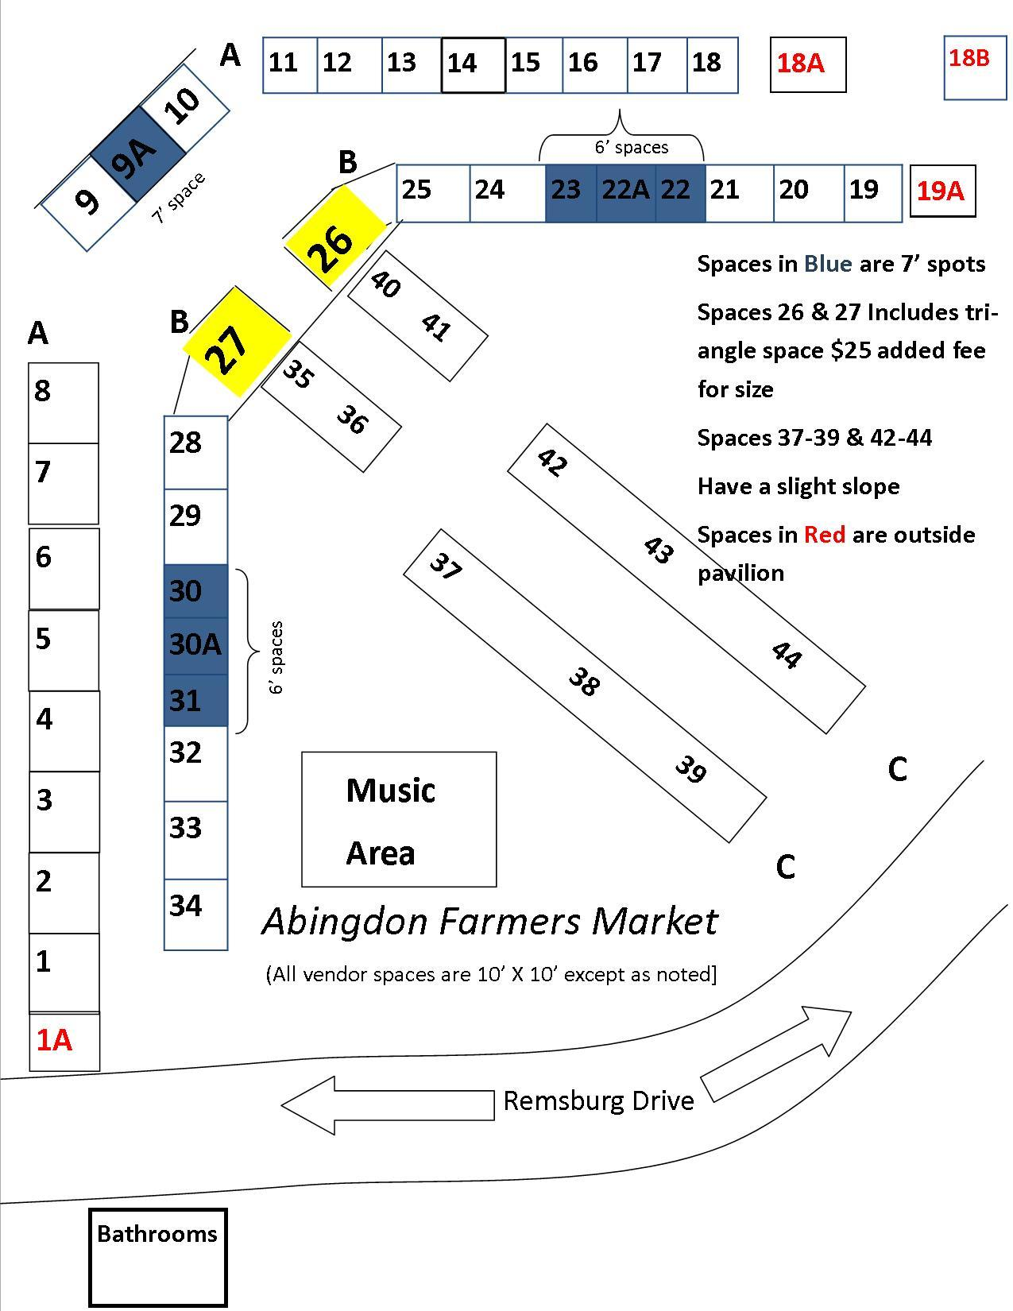

Abingdon Farmers Market Rules 2021
David McLeish, Market Manager 276-698-1434
abingdonmarket@gmail.com, www.abingdonfamersmarket.com

Vendor Categories: In fulfillment of its mission, the AFM strives to maintain the following ratio of vendors at the Market: Farm Products (70%) Prepared Foods (15%) and Arts/Crafts (15%). See below for a description of items allowed in each category:
Farm Products: Products grown, raised, or produced through agricultural activity, such as fruits, vegetables, plants, flowers, seeds, or animal products, including prepared foods and craft items made primarily from farm-raised or wild crafted items (Excludes wild crafted Mushrooms unless approved by USDA).
Prepared Foods: Homemade made from scratch, edible items including hot meals, candy, baked goods, jams, jellies, canned foods and beverages. Use of as many locally produced ingredients as possible is strongly encouraged.
Arts/Crafts: Non-edible handmade items such as carving, artwork, jewelry, soaps, lotions, wreaths, etc. Use of local materials is strongly encouraged.
General rules for all vendors: 1. From their written application and previous market history, each AFM vendor is placed into the category that best represents that vendor’s primary product(s) at Market. The majority of items brought to market over the entire season should reflect that primary category. The Market Manager will monitor these categories over the course of the season and reserve the right to re-categorize any vendors who have changed their primary products.
2. Items may not be purchased elsewhere for resale at the Abingdon Farmers Market.
3. Items not produced by the vendor, their family, or employees (as employees for your business) must have written approval for sale from the Market Manager/Steering Committee. The producer of the item must be clearly labeled at the point of sale.
4. Farm Vendors are required to clearly label products they did not grow including but not limited to prepared and wild crafted foods. All vendors are strongly encouraged to label non-farm products that used locally grown goods.
5. Compliance with all Health Department and Department of Agriculture guidelines and restrictions is the sole responsibility of each vendor, such as meat and egg temperature, organic labeling, etc. Upon request, vendors must demonstrate to the AFM Market Manager their compliance with all guidelines. All vendors who are planning to sell prepared food should contact Chris Salyer of the Virginia Department of Agriculture and Consumer Safety to discuss compliance with current inspection requirements. 276-220-3210 or Christopher.Salyer@vdacs.virginia.gov
Virginia’s Cottage Food Law lists prepared foods which may be sold at Farmers Markets without inspection:
http://lis.virginia.gov/cgi-bin/legp604.exe?131+ful+CHAP0285+pdf

6. Meats must be processed in a USDA inspected facility and have a Dept. of Agriculture stamp, except poultry and other meats exempted by VA law. All meat inspections are the responsibility of the vendor.

7. On behalf of the Steering Committee, the Market Manager has authority to inspect the origin of items sold at the Market to ensure that such sales conform to Market Rules. All vendors are subject to an on-site visit to verify local production at any point during the market season, including all sites of production. Routine farm visits are also ongoing, with the goal of visiting each farm every 2-3 years.

8. Any incident(s) of rule violation may be dealt with via the:
---AFM Vendor Incident Form, filed by manager, with reply by vendor.
---AFM Vendor Complaint/Suggestion form, to be completed by both parties, and mediated by the manager and Facilitator (and others as requested, to be interviewed separately by manager.) Vendors involved in either of these processes have rights of appeal to the entire Steering Committee, after completion of the form and process above.
Operations: 1. Saturday Regular Season Market will operate from the 1st Saturday in April through last Saturday in October. Tuesday Market runs 1st Tuesday in April through last Tuesday in September. At Abingdon Market Pavilion on Remsburg Drive in Abingdon. Hours of operation will be each Saturday from 8:00 a.m. – 1:00 p.m. and each Tuesday afternoon from 3:00 – 6:00 p.m for the Regular Season Market.
2. The AFM Holiday Farmers Market will begin the first Saturday in November (Daylight Savings Time change) and run through the Saturday prior to Christmas, from 10:00 a.m. – noon. All AFM rules still apply.

3. The AFM Winter Market is open the first and third Saturdays of Jan, Feb and March. From 10 a.m. – noon. All AFM rules still apply.

4. Vendors will have access to the Market one (1) hour prior to the opening time for the purpose of unloading and setting up merchandise, and they must exit the premises no later than one half hour [1/2] after the closing time. Several times each year vendors are asked to leave at closing time or soon after to accommodate other scheduled events at the Abingdon Market Pavilion.

5. No sales may be made prior to the official market opening time.

Fees:
Application Fee, must be paid with completed and signed Application - $25

Vendor Space Fees:
____ $300 Full Season: Section A
____ $180 Full Season: Section B, plus spots 1A and 18B (10 foot space) [spots 26 & 27 add $25}
____ $145 Full Season: Section B (6.7 foot space)
____ $150 Full Season: Section C (10 foot space along new walkway)
____ $ Full Season: Tuesday only—75% of above fees

Monthly, any space (any consecutive 4-wk period, Saturdays and Tues) $75

Weekly, any space (any consecutive Sat then Tues OR Tues then Sat) $25

Daily, any space (setting up for one Saturday OR Tuesday) $15

Returned check fee: $35

AFM Vendor Payment Schedule:

$25 Due with Completed and Signed Application - the 3rd Saturday in December.

$75 Due before AFM Market Close on the 3rd Saturday in January.

If this $25 and $75 (totaling $100) are not paid by these designated dates, then your vendor space preference will be moved to last when the vendor space assignment takes place.

To summarize, this means that a total of $100 is due by these Dec and Jan dates before vendor space assignments in February, and if not received on time then your space selection order will be moved to last.

After Vendor Space Assignment in the February Steering Committee Meeting (which all vendors are highly encouraged to attend), AFM Market Manager will send you the balance of how much you owe based on your Vendor Space Assignment.

50% of the Balance of what you owe based on your Vendor Space Assignment is due before the 1st Saturday in April (Market Open).

Remaining Balance of Vendor Space Fee is due before 1st Market in July.

Failure to Pay the Vendor Space Fee by the dates and times listed may result in Vendor Point penalties or not being allowed to set up at the market, based on AFM Market Rules.

            - It is the sole responsibility of the vendor to make sure his/her fees are paid on time.

- Full season fees include access to Holiday and Winter Markets.

Sales Tax:
Virginia State Law requires all vendors to register with the Virginia Department of Taxation, and to collect and report sales taxes. Information and applications can be obtained from the Virginia Department of Taxation, PO Box 1114, Richmond, VA 23218-1114. www.tax.virginia.gov Phone 804.440.2541. It is the responsibility of the individual vendor to comply with tax requirements.
Lease Agreements and Assignment of Space:
1. Full season vendors will be assigned regular spaces at the Market by the AFM Steering Committee, all vendors are urged to attend and take part in this February meeting. All other available spaces shall be assigned by the Market Manager. In assigning full season spaces points are assigned for:
Location: 2 pts Washington County, VA
Market Points: 1 pt /year of tenure since 2007
1 additional pt if Saturday season vendor in 2019 [attendance for 75% of the regular season]
2 more pts if Tues season vendor in 2019 [attendance for 75% of the regular season]
1 additional pt for 75% attendance at Holiday and Winter Markets, previous year
Rules violations: 1 pt deducted for each major infraction of rules in 2020. Pursuant to Vendor Incident and Vendor Complaint processes, to ensure due process for all involved.

2. Vending space size will be either 10’x10’ or 6.7’x10’. Regardless of width of space, a 10 foot aisle down the middle of the pavilion must be kept clear of produce or display items for pedestrian/customer use at all times.

3. A shared lease is welcomed, but all parties must submit an application and pay fees. Subleasing of spaces is not allowed.

4. The Market Manager, on behalf of the Steering Committee, reserves the right to cancel any lease, and to change space allocations when it is considered to be in the best interest of the Market operation.

5. Vendors should be on-site and ready to sell no later than the start of market. If running late, any paid vendor may reserve his/her spot by contacting the Market Manager a half hour before market opening. If unable to attend any market date, please give the Market Manager as much advance notice as possible, at least one hour before market opening. So that another vendor has time to set up in that space. Failure to observe these policies will result in warnings from the AFM Manager. After a written warning for ‘no-shows’, the Manager has the right to assign an empty space to another vendor on any given market day. A vendor arriving late, without advance notice as above, may be assigned another space that day as available.

6. Both full season and monthly vendors must attend and sell from their assigned space most of the season or risk losing their assigned space (unless notifying the Market Manager in advance).

7. All vendors shall be held responsible for the actions of their employees, agents, or persons working in concert with their stand.

The AFM Steering Committee has the authority to terminate the lease of any vendor who fails to comply with the rules and regulations of the Abingdon Farmers Market.

Town of Abingdon Market Pavilion Rules (This part handed out in packet, for Apr. educational/training meeting.)

Sanitation, Health and Safety:
1. Vendors are responsible for the collection and removal of all refuse generated from sales and activity at their space, leaving it reasonably clean.

2. It is unlawful to sell open containers or consume alcoholic beverages on the Market property.

3. Vendors must keep all merchandise, refuse and personal property within the defined space allocated in their rental agreements.

4. No vendor shall permit seepage or leakage of water or fluids from any part of their space into the public areas or other vendors’ spaces.

5. Children under 14 years of age must be supervised by an adult at the Market. Bicycles, scooters, skateboards and other similar devices are prohibited in the Market pavilion at all times.

6. Vendors may not bring live animals for sale onto Market property except as provided by State or Federal laws (i.e. hearing, guide and service animals).

7. Vendors are responsible for the individual safeguarding of their products, supplies and money. The AFM or Town of Abingdon is not responsible for loss or theft.

8. Vendor (lessee), by signing the Vendor Application, agrees to protect and hold the AFM (leaser) and the Town of Abingdon harmless and to indemnify the leaser from any and all claims, demands, suits, actions, judgments and recoveries for or on account of damage, theft or injury (including death) to property or person occurring as a result of lessee’s use of the leased property and any other cause whatsoever.

9. Dogs are not allowed at Market, except for service dogs.

Structural:
- Vendors must provide their own equipment and any set-up materials for display of items.

- No vendor shall be allowed to make any changes or alterations to their assigned spaces without permission from the Market Manager.

- Use of electricity and water is by request on the vendor application, and is made available by the AMP Facility Manager. Electricity and water shall be turned off before the Facility Manager leaves.

- No vendor shall erect an additional structure at the market without permission from the Market Manager.

- Any needed repairs, hazardous conditions or problems in the Market area should be reported to the Market Manager. Persons causing damage to the pavilion structure or landscaping may be held financially liable for the cost of repair or replacement.

- No extension cords across pathways.

General:
- Proper dress and an orderly space will be expected from all vendors. Proper language for a family atmosphere will be required.

- It is the responsibility of vendors to satisfy customer complaints. The Market Manager, in consultation with Steering Committee, may cancel a vendor’s lease in the case of multiple customer complaints or if vendor activity jeopardizes the smooth running of the Market.

- No person shall make a public outcry, do “hawking” or give any musical or other entertainment for the purpose of drawing customers or attracting attention.

- Item prices are suggested to be within the average range of other like items at the AFM. Samples given should be limited to small “tastes” with respect to other vendors selling the same items.

- All vendor signage must be contained within the vendor’s assigned rental space.

- No open flames (grills) are permitted on Market property without the prior approval of the Facility Manager.

Parking:
- Vendor spaces will be assigned and reserved for their use only. Vendors are not permitted to park overnight at the market pavilion. Only the assigned vendor may park and sell from their reserved space. Only one (1) vehicle per vendor space behind the market pavilion.

- All vehicles must enter and leave the Market area through the provided entrances and exits. Vendors will be expected to respect the parking regulations established by the Town of Abingdon and to park in such a way as to keep Market traffic lanes open for travel. This will be enforced by the Market Manager and Facility Manager.

- To facilitate bulk purchases, customers or their vendors may request temporary parking passes, available from the Market or Facility Managers.

- Each vendor must drive in a careful manner and at a rate of speed that does not endanger the property or persons in and around the Market.

- Handicap parking is available by request in the rear of the property.

- Any vendor not parked at an “A” vendor space must park across Remsburg Drive from the Market Pavilion. Please park closer to Main Street in the town or bank parking lots, thereby reserving for our customers those spaces closest to the market.

